**DAILY ONLINE ACTIVITIES SUMMARY**

|  |  |  |  |  |  |  |  |  |
| --- | --- | --- | --- | --- | --- | --- | --- | --- |
| **Date:** | **21/05/2020** | | | | | **Name:** | **PRANEETA P HANDRAL** | |
| **Sem & Sec** | **4thSEM. & ‘B’ SEC.** | | | | | **USN:** | **4AL19CS401** | |
| **Online Test Summary** | | | | | | | | |
| **Subject** | | **MICRO-CONTROLLER AND EMBEDDED SYSTEMS** | | | | | | |
| **Max. Marks** | | **30** | | **Score** | | | **21** | |
| **Certification Course Summary** | | | | | | | | |
| **Course** | **Python for Machine Learning** | | | | | | | |
| **Certificate Provider** | | | **Greatlearning Academy** | | **Duration** | | | **5 Hrs.** |
| **Coding Challenges** | | | | | | | | |
| **Problem Statement: Crete the SLL, and then Reverse the Link in SLL until Head becomes NULL. Each Time Reversing the Link, Head must be moved to next immediate node.** | | | | | | | | |
| **Status:** **Executed.** | | | | | | | | |
| **Uploaded the report in Github** | | | | | **Yes** | | | |
| **If yes Repository name** | | | | | **LockdownCoding** | | | |
| **Uploaded the report in slack** | | | | | **Yes** | | | |

**Online Test Summary:** 18CS44 test was scheduled from 10:00 am to 10:30 am.The portion for the IA was 1 st module there were 25 questions and the time assigned was 40 minutes the questions were mcq type. But there was an issue with the time mentioned, so that we got only 30mins. to finish the test. The time was not sufficient to answer all the questions. There were 30 questions of 1 marks respectively.

**Online Certification Course Summary:** Today I have learnt about conditional statements and execute the code and to achieve the output and some of the basic conditional statements programs.

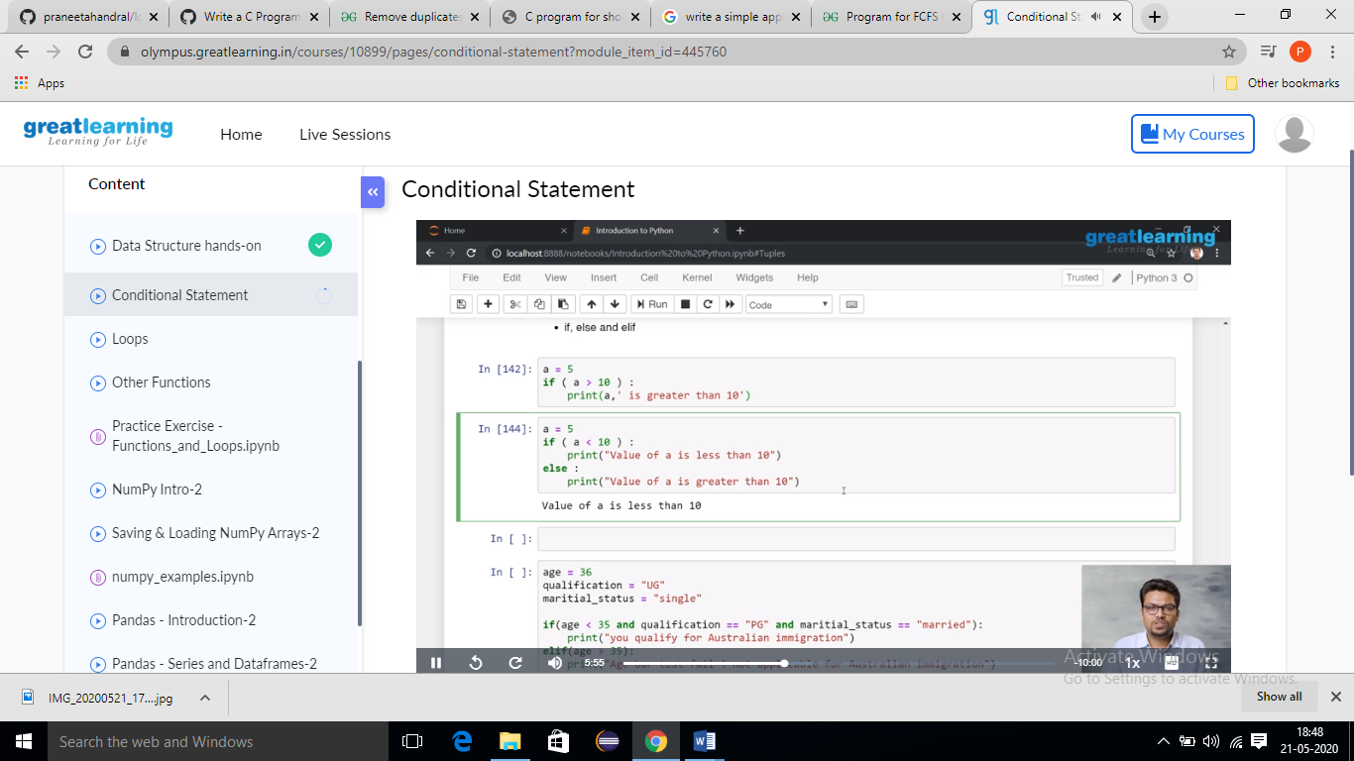

**Online Coding Summary:**Today I received one program from Prof.Venkatesh CSE Dept. The program is mentioned above(pg.01). to my GitHub repository and I’ve shared the snapshot below.

